**Spring 2022**

SAHAKARINI ESTABLISHED 1979 CAMROSE AB

**Pipal Tree, Bangalore, India Project**

Aid to support the Upliftment of tribal girls and boys from forest communities. Total contract CA$14,161 (Jun 2021 - May 2022).

Pipal Tree, Bangalore, India engages Tribal peoples, dry land farmers, and Adivasi (Tribal) children. Sahakarini and Pipal Tree help to promote a sense of self-identity and dignity in children, prevent school dropout and develop leadership skills.

The most recent project with Pipal Tree is the Children’s Clubs/Learning Centers. These develop female and male Adivasi youth as mentors to tribal children, as they teach and strengthen community identity, gender parity and life skill competencies.

Tribal youth are trained to create a friendly and culturally safe learning environment for the tribal children to strengthen their academics and express themselves. Creative methodologies, in their first language, include traditional games, folk art forms, dance, and hand held devices that provide a self-paced, interactive and experiential learning tool and content. Parents, community and stakeholders are integrated into the gamified and curricula based learning processes as co-participants.

(Wrap text aound this picture)

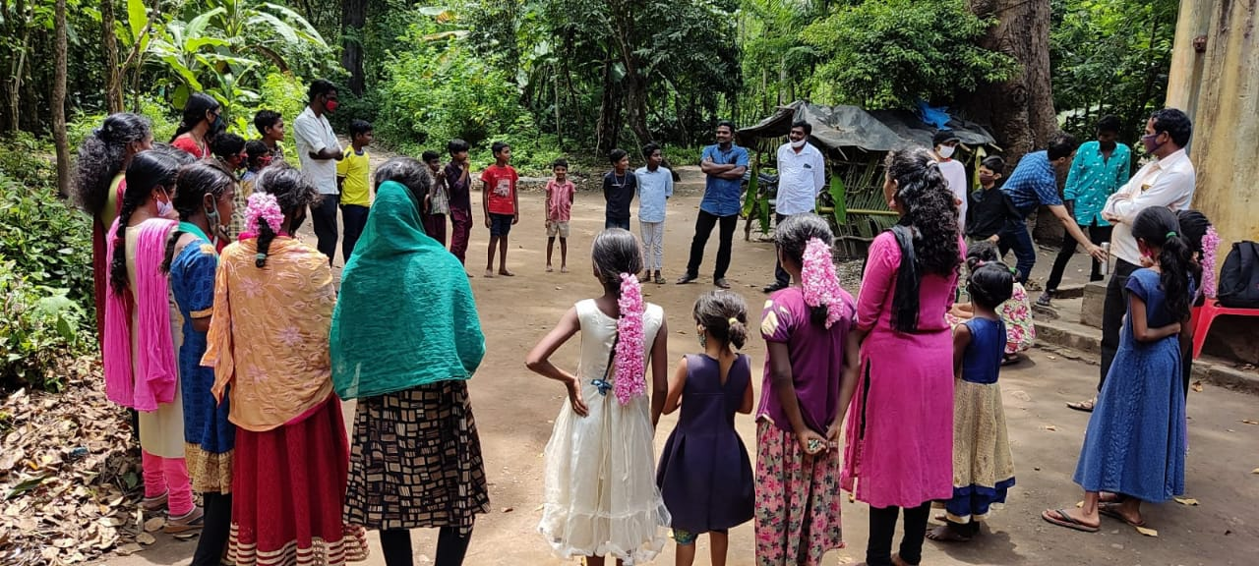

How to Donate

**What fun it is!**

* 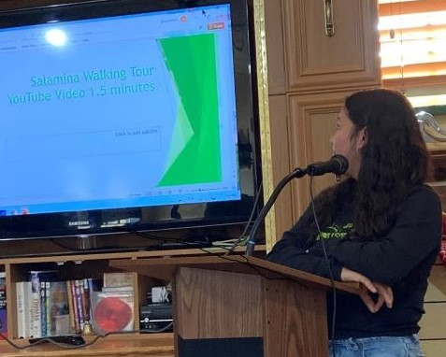 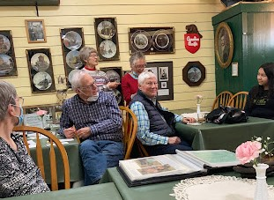

It is such fun to be together again and better yet when our fun helps others. Our small group fundraisers Loaves and Fishes Re-Imagined, are proving it. A number of groups have already met and more are coming soon. Amidst the troubles everywhere, we can provide hope and help. If you would like to be a host or get more information on how you can participate, email us at Sahakarini@gmail.com and join the fun.

**The Walk of the Sandals**

Did you know that you can book a week's adventure with the Sahakarini Sandals this year? As part of the 2021- 2022"Loaves and Fishes Reimagined" we are inviting Camrosians to take these well-storied sandals along with you on your own travels - whether to an exotic location or your backyard - and to document their travels with some photos for us to share on our social media. Suggested donation for each weekly rental is $100 and can arranged through Rajan or Margaret Rathnavalu (rajan.rathnavalu@yahoo.ca / megandrath@yahoo.ca)

**Message from the President**

Welcome to Spring and to our Newsletter. We are excited about all of our “RE-IMAGINED” fundraising efforts, our use of new communications platforms and all the new ideas that are revitalizing Sahakarini on many levels. This Sahakarini evolution is being fully embraced by the members of the board and I hope by you as well. As with past newsletters, the objective is to keep you informed and updated on all things Sahakarini. I know how you value our organization and your own personal experiences and connections with Sahakarini. It is this connection that enables Sahakarini to be over 42 years old. Thank you for your continued interest and support.

Enjoy our Spring 2022 Newsletter.

Litsa Tryphonopoulos,

Sahakarini Chairperson

With respect and in gratitude,

Litsa Tryphonopoulos

**New Opportunities to Sponsor New Projects**

Over the past year Sahakarini has experienced some unique member based sponsorships, involving substantial financial donations, of designated projects. In one case a 3-family group totally funded a community-based water supply project, of their choosing, in Africa. In the other case an individual provided a substantial donation, to be matched by Sahakarini, in a much needed renovation of a Childcare centre in South

America. These creative examples of project sponsorship, with major donor(s) funding, provides individual donors with the opportunity to not only choose the project they wish to support but also in which part of the Developing World it should occur. Sahakarini’s role involves providing tax receipts to the donors, setting up a project contract and managing the application of the contract. The end result becomes a successful partnership of funding and management components.

Michael Mucz, Board Member

***Would you like to become a supporter of Sahakarini by making small, regular monthly donations? see the Sahakarini web page menu marked Donations (sahakarini.org) on “HOW TO BECOME A MONTHLY Donor”.***

**FUNDRAISING**

Considering having a garage sale? Why not help out one of our many important projects by donating your garage sale proceeds to Sahakarini. Let us know of your intention to do so and provide us with the date and time then we will advertise your sale on our facebook page. Our email is sahakarini@gmail.com or call the office at 780-672-8222.

Plan a group fundraiser – Loaves and Fishes Re-Imagined. Invite your friends to learn about the work of Sahakarini.

**Save the Dates**

**Sahakarini Bottle Drive**

10:00 am - 2:00 pm May 28th, 2022

Parking lot of Quilting From The Heart

**Online Auction** May 23rd, 2022 beginning at 6:00pm and will close on June 6th, 2022, at 6:00. Winners will be announced at the AGM June 6th.

Successful bidders can pick up the auction items on Tuesday June 7th in the office.

AGM June 6th, 2022, 6:30 pm

at Messiah Lutheran Church

Coffee/Tea and Dessert

Guest Speaker: John Pattinson

Office: 4920-50 Street, Main Street Mews Building, Box 1685, Camrose, AB T4V 1X6. Phone: 780 672 8222 Office Manager Carolyn Andersen

Email:sahakarini@gmail.org Website: www.sahakarini.org YouTube: Sahakarini Local Effort for Global Challenges

The Sahakarini Board would like to thank our outgoing board member and Augustana student, Josiah Afriye for sponsoring our Spring Newsletter. We thank him for his generosity and contribution to Sahakarini i